Media List

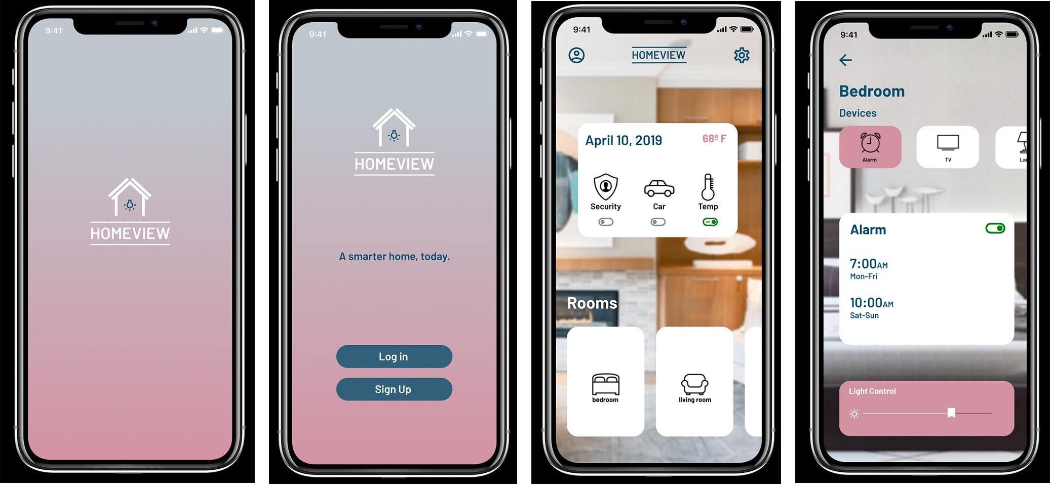

Smart Home Personal Project, self (hoemviewj.jpg)

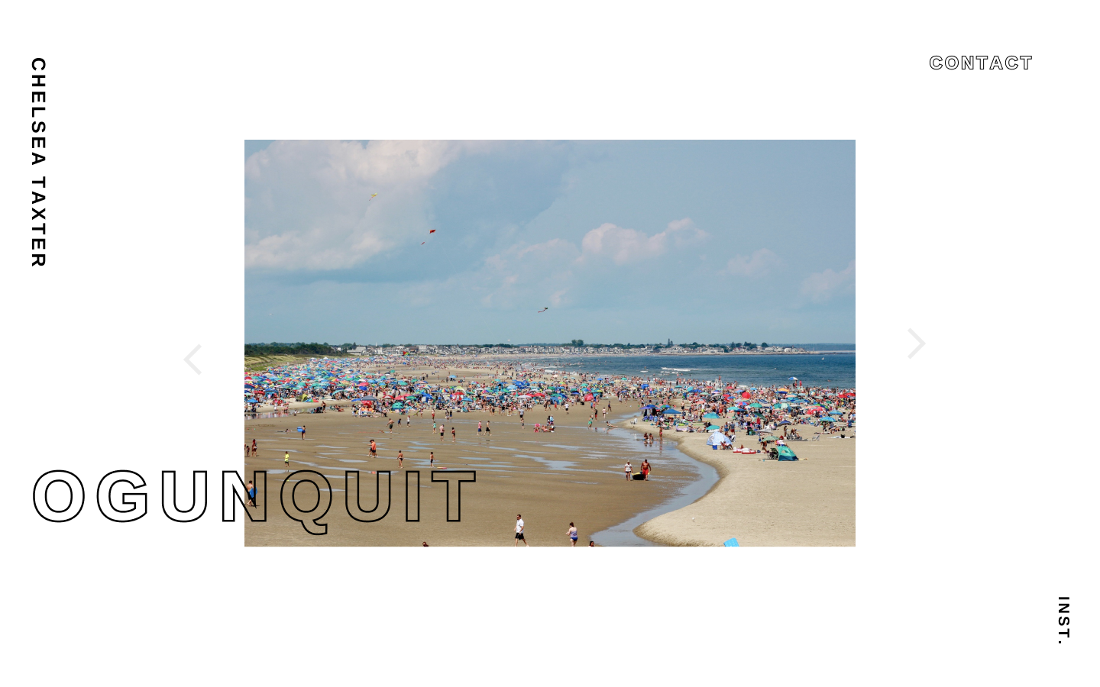

Photography Personal Project, self, (OGUN.png)

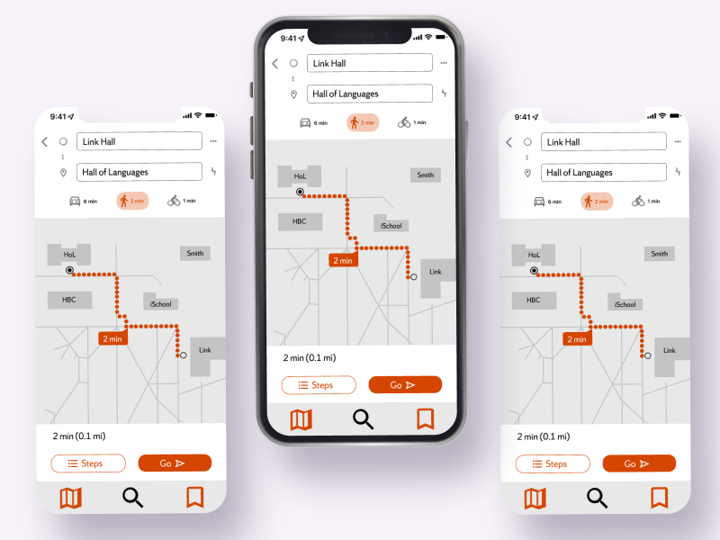

School Map Personal, self (hoemviewmc5.png)



self, (linkedinpic.jpg)

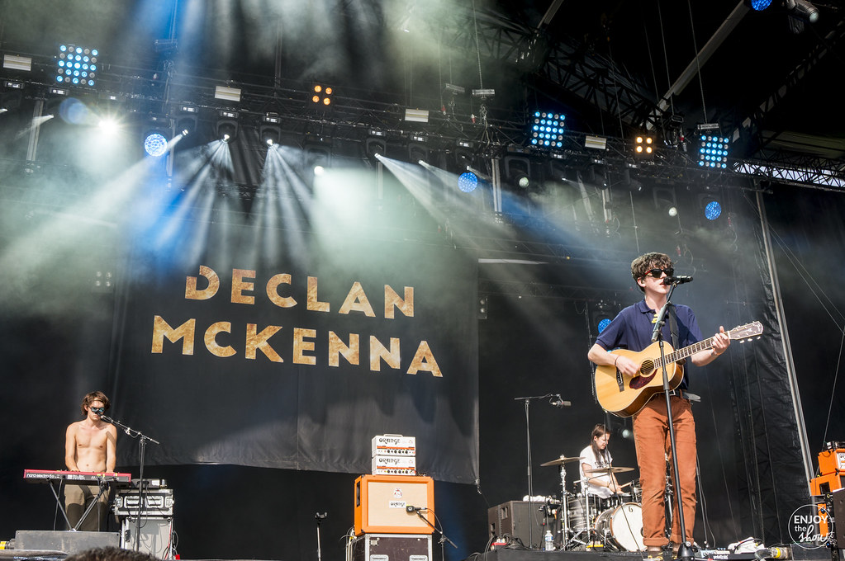

Labeled for noncommercial reuse) <https://www.flickr.com/photos/enjoytheshownet/36082574633/>

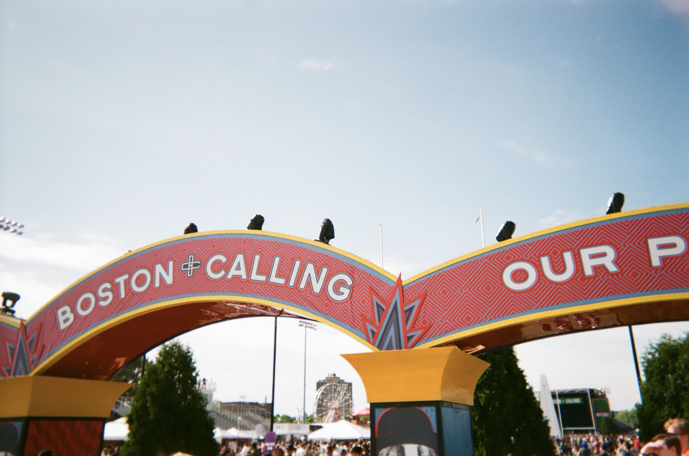

(self, 000286340025.jpg)



(labeled for noncommercial reuse, <https://commons.wikimedia.org/wiki/File:A24_logo.svg>)